CSA1302-THEORY OF COMPUTATION
LAB EXPERIMENTS USING C

NAME : P SUDHARSHAN REDDY
REG NO : 192372204

1. Write a C program to check whether a given string belongs to the language defined
by a Context Free Grammar (CFG)
S → 0A1 A → 0A | 1A | ε

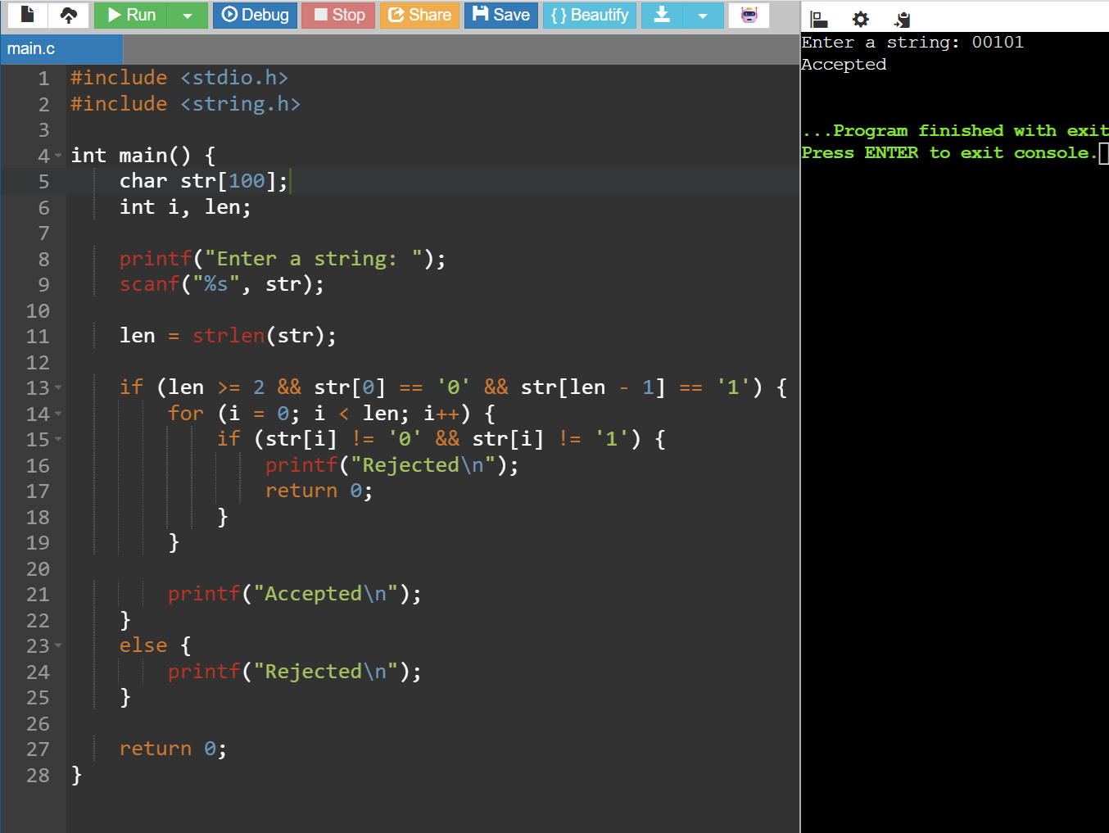

2. Write a C program to check whether a given string belongs to the language defined
by a Context Free Grammar (CFG)
S → 0S0 | 1S1 | 0 | 1 | ε
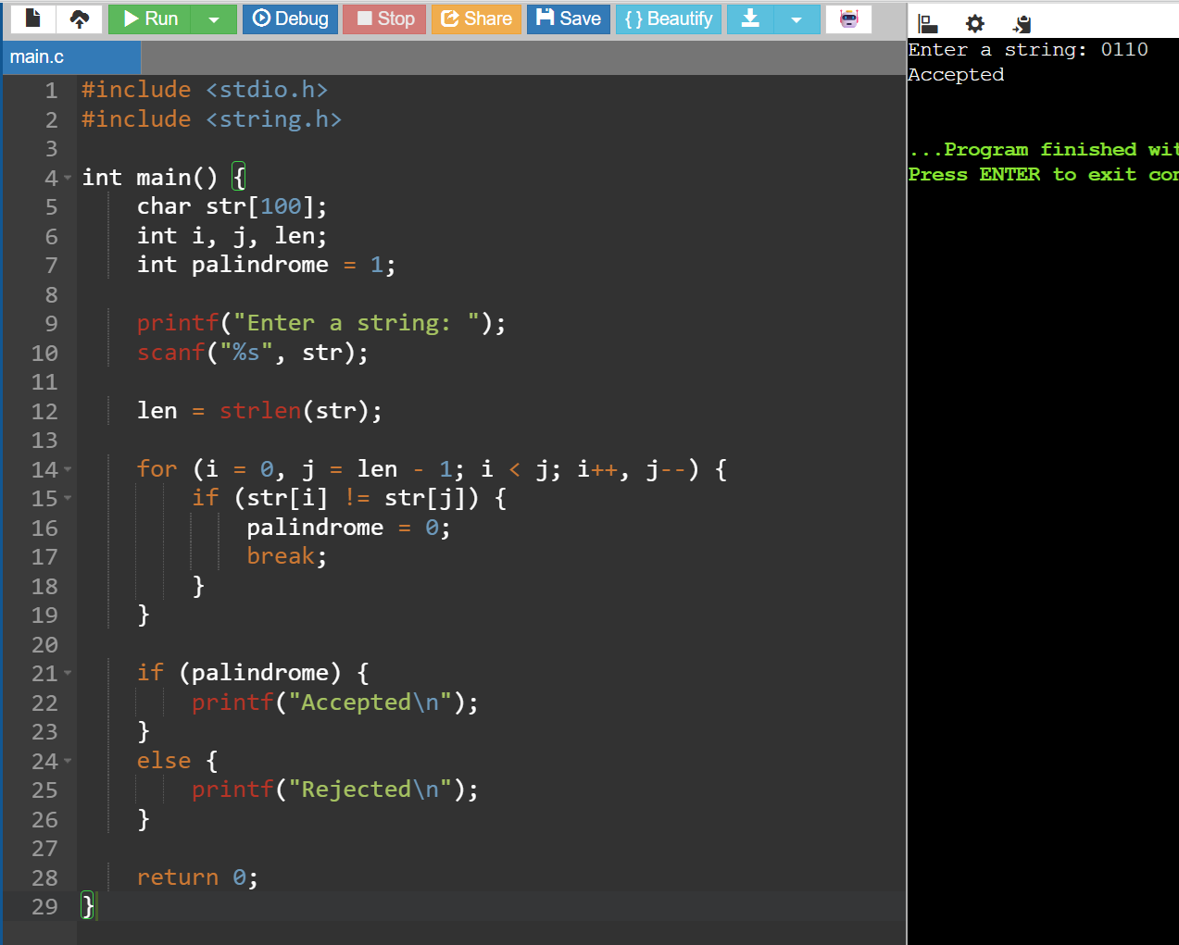

3.write a C program to check whether a given string belongs to the language defined
by a Context Free Grammar (CFG)
S → 0S0 | A A → 1A | ε
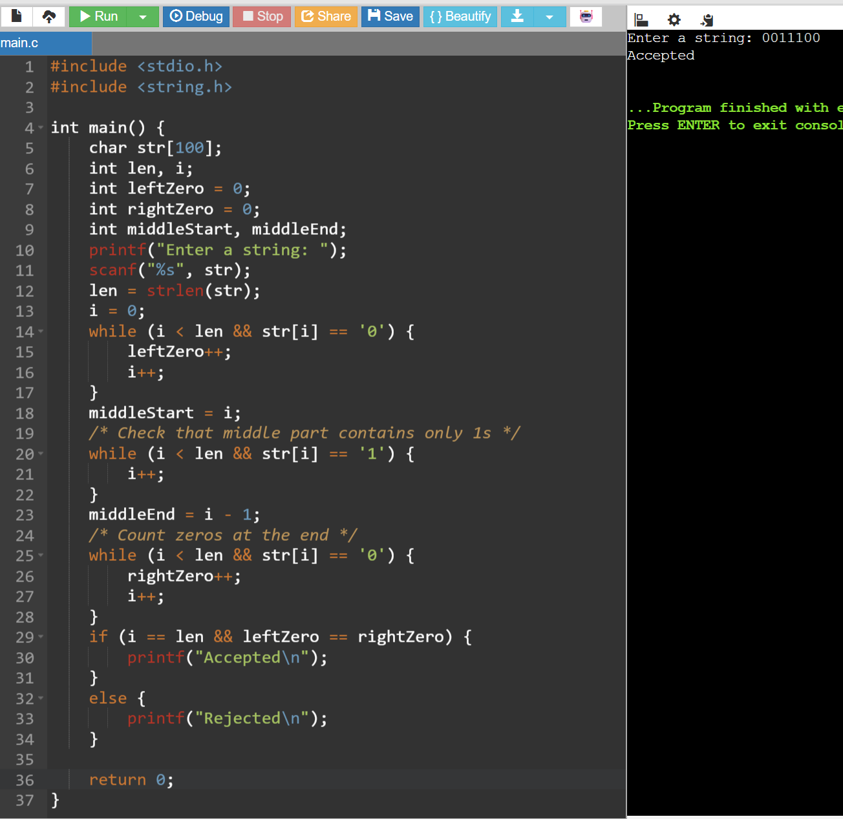

6. Write a C program to check whether a given string belongs to the language defined
by a Context Free Grammar (CFG)
S → 0S1 | ε
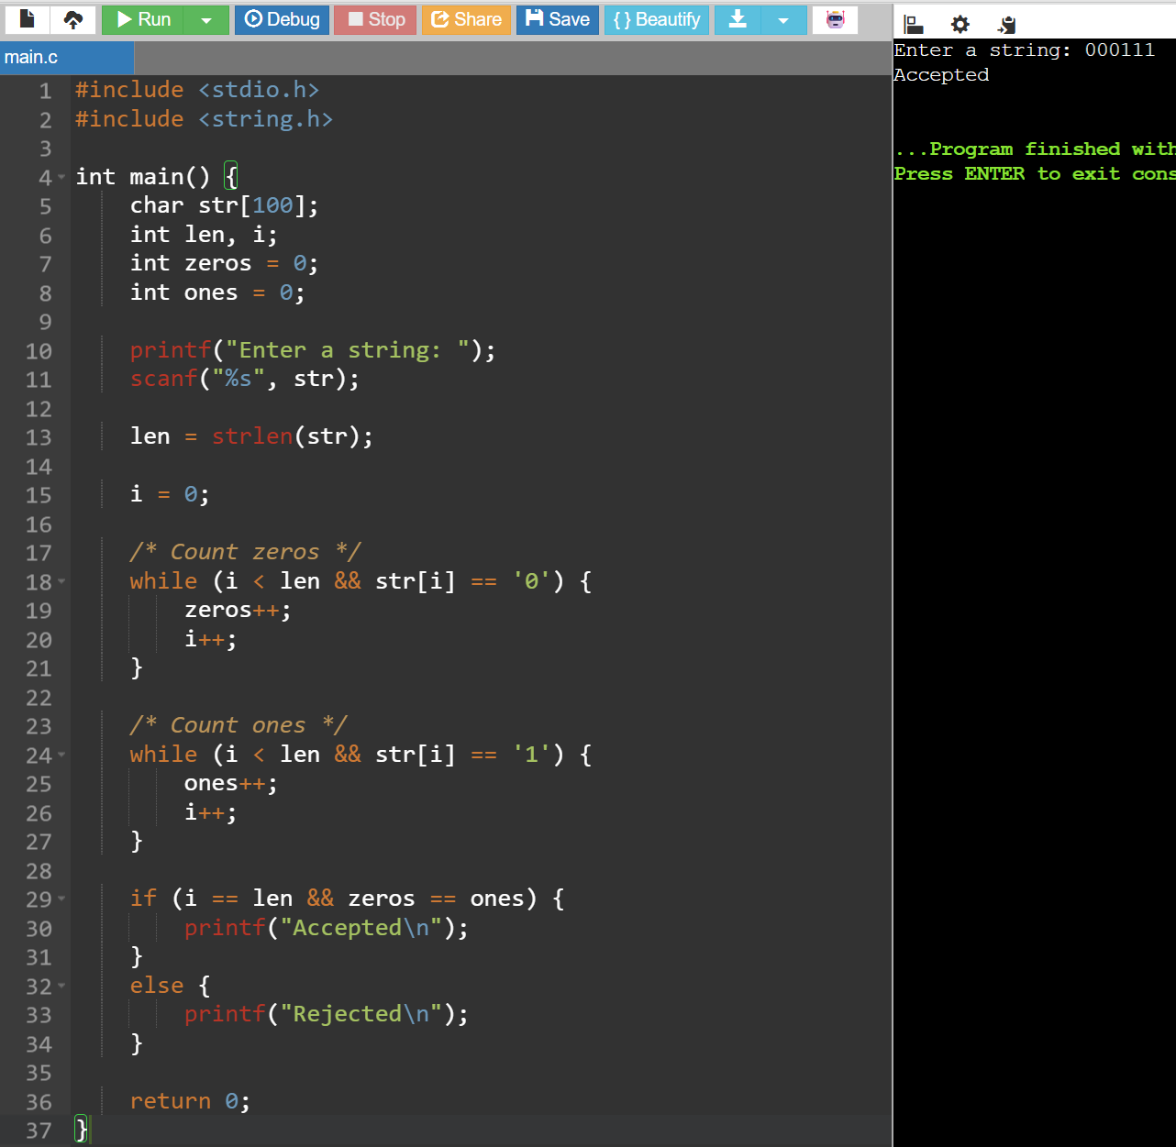

7. Write a C program to check whether a given string belongs to the language defined
by a Context Free Grammar (CFG)
S → A101A, A → 0A | 1A | ε
